**Summarize the question about conversion/apostasy that you wish to study (500 words). State why it interests you, and how it connects to the themes discussed in the course. This could be our discussions of conversion and boundary-formation, about the intersections of conversion and gender or slavery, about bodily practices associated with religious identity, and so on.**

My question of interest: Do all conversion narratives have an overarching similarity in terms of narration? This question interests me because I have always been amazed at the similarity in the overarching storyline among many popular fairy tales and parables.

Take, for example, Snow White. The story begins in a peaceful mood. Then a disturbance comes (the evil queen and the magic mirror), which sets the story into chaos (Snow White going into the forest), and then she found a great peaceful place again (the cottage of the dwarves). The story goes on, with multiple times when the evil seemingly triumphed, and in the end, evil was defeated (the death of the evil queen), and peace was returned. Looking at other fairy tales, it is observable that many of them follow a similar structure: peace -> (evil -> peace)*a few times -> peace/triumph.

Modern English literature, on the other hand, usually doesn’t end happily. For example, the mood of the storyline of *The Old Man and the Sea* by Ernest Hemingway reaches a peak when the old man caught a marlin, and declined ever since. The narrative of Benjy’s chapter in *The Sound and the Fury* includes short lived euphoria scrambled together with short lived misery within a neutral narration. The progress of narrative moods of texts can group them into literature genres.

Having gone through this course, I have always wondered if ancient conversion narratives followed a similar overarching change of moods. Do they all follow a similar change in mood? Especially, because many of them can’t be corroborated by archaeological evidence, I wonder if they are all inspired by the narratives of their predecessors, and thus, all share a common storyline.

In class, we have read excerpts from Epiphanius as well as Joseph and Aseneth. If we consider the storylines to be terrains with mountains and valleys, reading only excerpts of a storyline would be just visiting a tiny part of the terrain, and without reading more, it is impossible to determine whether we are at a mountain or a valley in the terrain. One might read two excerpts from conversion narratives that are both “mountains” and conclude that the experience of conversion is joyous. If only I could generate a “terrain map” of the book, someone who wants to read excerpts from the book can select to read a few selections that are rather representative of the book’s narration as a whole. Just selecting excerpts that represent “valleys” and “mountains” probably won’t make a objectively representative selection of text, but it will surely help, and it’s highly improbable that there will be anything that generates a fair representative selection of text. This “terrain map” will also help people who wish to read texts comparatively find comparative moments across different texts.

If we can find narratives from people of different backgrounds, I plan to also compare the texts to examine how they compare to each other and what might have caused that. For example, the story of the conversion of a slave, or a woman, might be different from that of an ordinary person. These “special groups” might have had a much bigger increase in their quality of life through conversion. I want to find out whether this hypothesis can be corroborated by their narratives.

**Compose a literature review of at least 6 peer-reviewed sources that will form the foundation of your project. For each source, identify it, briefly summarize its key point(s) in a sentence, and describe in 1-2 sentences how you’ll use/build upon this evidence in your project. Two of these sources must come from our syllabus. Please also indicate what primary sources you think you will use.**

1. *Panarion by Epiphanius*. Used as one of the data texts.
2. *Joseph and Aseneth*. Used as one of the data texts.
3. *From Once Upon a Time to Happily Ever After: Tracking Emotions in Novels and Fairy Tales* by Saif Mohammad. Used as a reference to how sentiment analysis is done in fairy tales. <https://arxiv.org/pdf/1309.5909.pdf>
4. *AFINN* by Finn Årup Nielsen. This lexicon gives a ranking from -5 to 5 for 2476 common English words based what feeling they probably evoke. <http://www2.imm.dtu.dk/pubdb/pubs/6010-full.html>
5. *Artificial Empathy: Using Vector Space Modeling and Mixed Scope Alignment to Infer Emotional States of Characters in Stories* by Ryan Cherian Alexander. As a possible better model than AFINN scoring as AFINN words are mostly confined to modern English words. <http://groups.csail.mit.edu/genesis/papers/2016%20Ryan%20Alexander.pdf>
6. *Interpreting Author Intentions by Analyzing Story Modulation* by Suri C. Bandler. Can be used in conjunction with the previous research to analyze the logic within conversion narratives. <http://groups.csail.mit.edu/genesis/papers/2019%20Suri%20Bandler.pdf>

**3. Propose, explain, and defend your project format and share why it interests you (300 words). You may choose to write a brilliantly concise and beautifully written 1,500-word essay or its creative equivalent, such as a work of art, a video, a board game, a magazine spread, an infographic…the options are endless, limited only by your own creativity and commitment.**

I plan for my project to have two parts, with the second part building upon the progress made in the first part.

The first part will be a sentiment analysis purely based on the words used in the text. I plan to plot the polarity of each continuous bin of text (e.g. every 100 words) against the progress of the text, where polarity is defined as such, directly taken from the research of my statistics professor:

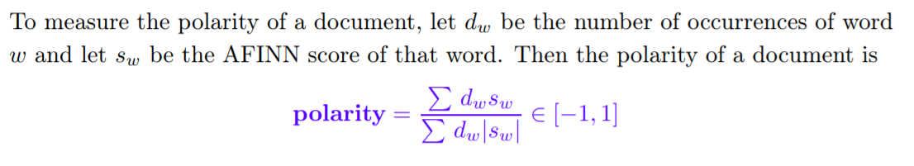

(i.e. this calculates the polarity as how much text is leaning toward positive or negative. If there are half positive words and half negative words in the text, the polarity will be 0. If the sum of the weighted score of all the positive text outnumbers that of the negative text with a 3 to 1 ratio, the polarity would be +0.5.)

The graphs may be plotted in a color scale like such:

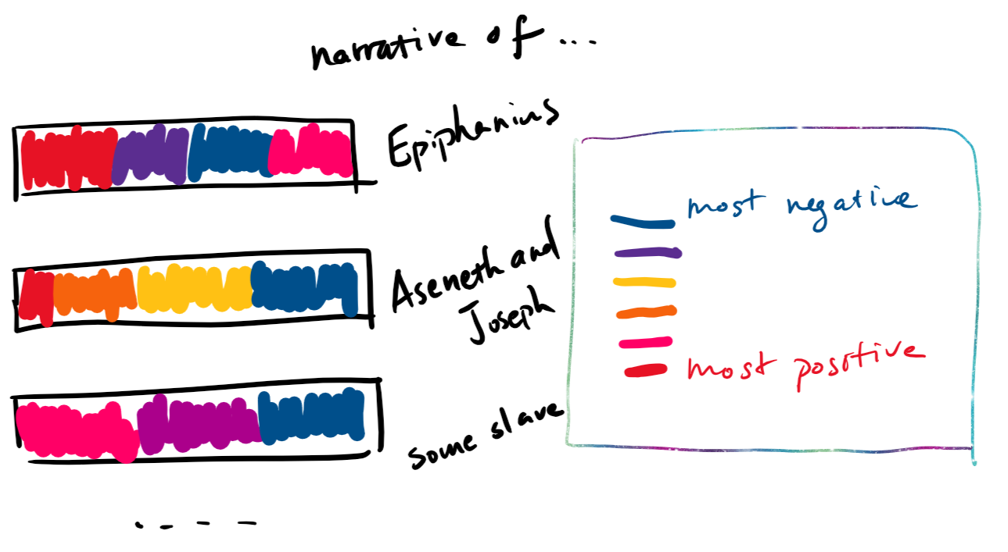

Where the color denotes the polarity of each continuous fixed width “bin” (i.e. window of observations) of words. I will then do the same steps described above again, but this time the width of the bins adapt to the length of each chapter.

The second part of the project is the ambitious part. I plan to try to adapt a few interesting research projects that I have stumbled upon. These research projects, made by students in the Genesis Lab at MIT CSAIL. One focuses on understanding the logic working behind story narrations, and it has been shown to quite successfully extract the inner logic behind Shakespeare’s *Hamlet* ([link to YouTube video demo](https://youtu.be/7XvgBI2KV28?t=1519)). Another focuses on exploring the author intentions behind words. I wish to extract the logic and author intentions behind the narratives (without reading them, lazy me) and along the way, learn the inner workings of the program and test out how well the model works against an arbitrary piece of text. If I spend the time into it, this project will have long-lasting benefits to me far beyond the duration of this seminar.

**4. List any questions or concerns you have as you undertake this project.**

Will we be able to find enough conversion narratives of people of different backgrounds to make comparisons?

Will the AFINN method work with translations of ancient texts that I have consistently found not colorful in terms of mood?

Will I be able to figure out what the researchers are talking about in their 100-page masters theses and adapt their program for my purpose?